ASSIGNMENT – 02

REQUIREMENT - Constructors, setters and getters
Usage of a particular constructor for a specific class:
We use constructors to initialize data members properly, avoid garbage values, set default state, create fully ready objects and support different ways of creating objects.
class User{};
Used default constructor in user class so that when we create an array object it doesn’t assign garbage values to it

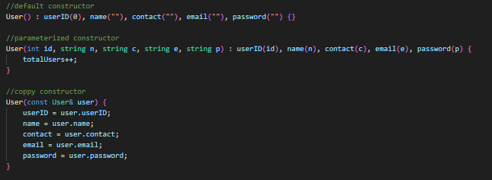

Used parameterized constructor to create instances with real data as we did in main()



Copy constructors are used when objects are passed by value. Used copy constructor to ccopy one user into another user safely, preventing shallow copy issues



class VehicleDetails{};
Used default constructor that creates empty details used inside Vehicle class (composition)
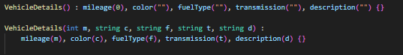

Used parameterized constructor as without it details cannot be passed to Vehicle class


class Vehicle{};
Used default constructor

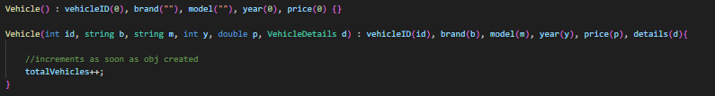

as in marketplaceSystem class we declare array of objects that require a default constructor

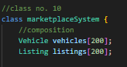

Used parameterized constructor that increments totalVehicles by 1 as soon as an object is created along with its parameters



class Message{};
We need a default constructor if creating an empty Message object and a parameterized constructor as without it sending a message is not possible
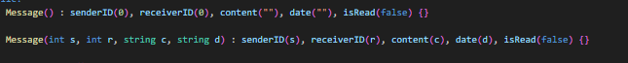

class Favorites{};
Only a parameterized constructor is used because it prevents random memory

Ensures an empty Favorites list when Buyer is created. It auto-constructs when Buyer is created
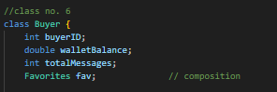
class Buyer{};
Used default constructor because it is needed if creating empty Buyer. We also create a parameterized constructor as it sets values, links Buyer to User (aggregation) and initializes totalMessages to 0

class Seller{};
Used default constructor because it is needed if creating empty Seller. We also create a parameterized constructor as it sets values, links Seller to User (aggregation) and initializes totalMessages and totalListings to 0
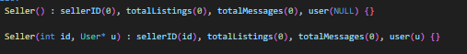

class Admin{};
Used default constructor because it is needed if creating empty Admin. We also create a parameterized constructor as it sets values, links Admin to User (aggregation) and initializes actionsPerformed to 0 and isSuperAdmin to false

class Listing{};
Default constructor resets listing to default when deleting. We also create a parameterized constructor as it sets values when object is created

class marketplaceSystem{};
We use a default constructor because we are using pointer arrays (objects) ensuring program safety and an empty start for all pointers. If we don’t set to NULL they will contain garbage addresses and the program may crash when accessed

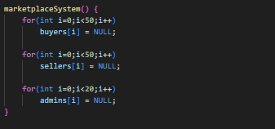

You may use constructor overloading, if necessary, with proper reasoning:
Function Overloading: Same function name, same class but different parameter list
Class Vehicle{};
Enabling simple updation of Price

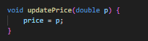

compile-time polymorphism:
reusing the same function with different parameters we can update price with discount as well

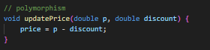

class marketplaceSystem{};
Searching vehicle by brand only

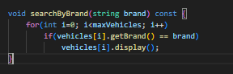

Using function overloading, we search vehicle by both brand and model

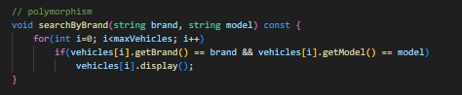

REQUIREMENT - Static Members
Explain why you made it static data member and member function:
data member(s):
class User{};
class User {
...

static int totalUsers;
};

int User::totalUsers = 0;

class Vehicle{};
class Vehicle {
...

static int totalVehicles;
};

int Vehicle::totalVehicles = 0;

Explanation:
totalUsers and totalVehicles are shared across all objects of their respective classes. These variables are meant to keep a global count of all users or vehicles created in the system, no matter which object is being used.
They exist only once in memory for the entire class, not per object. Every object can access and modify it, but they all refer to the same memory location. They are useful for counters, shared settings, or constants relevant to the class as a whole.

member function(s):
class User {
...

static int totalUsers;

public:
...

//method no. 3
static void showTotalUsers() {
cout << "Total Users: " << totalUsers << endl;
cout << "-------------------------------------------" << endl;
}
};

int User::totalUsers = 0;

totalUsers doesn’t belong to a single user, it counts all users in the system
class Vehicle {
...

static int totalVehicles;

public:
...

static void showTotalVehicles() {
cout << "Total Vehicles: " << totalVehicles << endl;
cout << "-------------------------------------------" << endl;
}
};

int Vehicle::totalVehicles = 0;

Explanation: A static function can access only static data members of the class. Since we want to display the total users or vehicles without needing to create an object of the class, we use static functions:
User::showTotalUsers();
Vehicle::showTotalVehicles();

REQUIREMENT - Composition & Aggregation
identify and implement at least 2 composition and 2 aggregation:
Composition:
Vehicle contains VehicleDetails

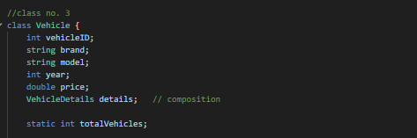

Buyer contains favorites

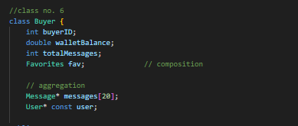

marketplaceSystem contains Vehicle[ ] and Listing[ ]

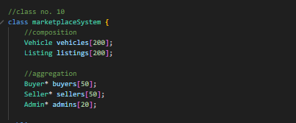

Aggregation:
Buyer -> User*



Seller -> User*

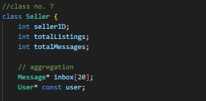

Admin -> User*

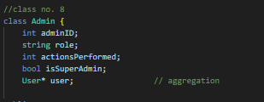

REQUIREMENT – Replication of website (www.pakwheels.com)
Replicated website segment screenshots along with code snippets:
There are many features used in the code but highlighting some of them
- User Profile Creation
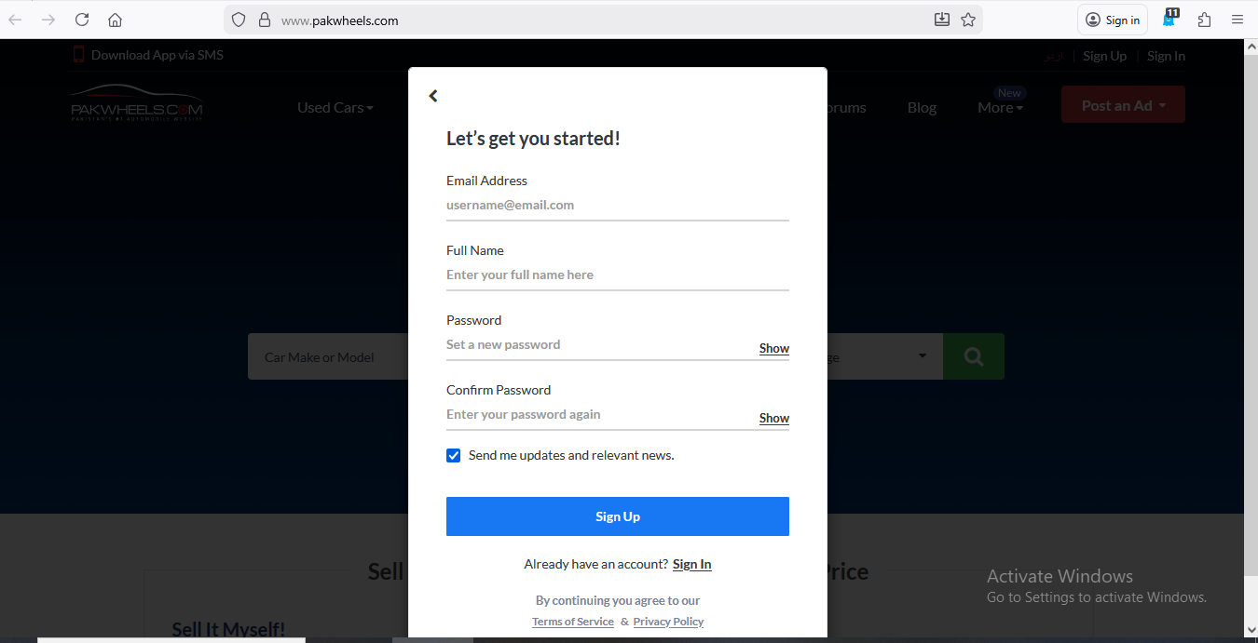
Code snippet of class and functionality in main():

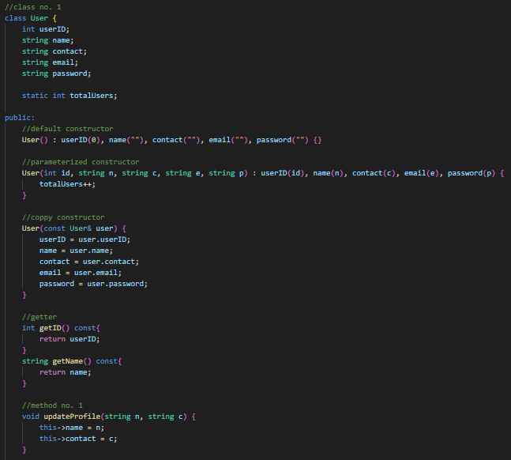

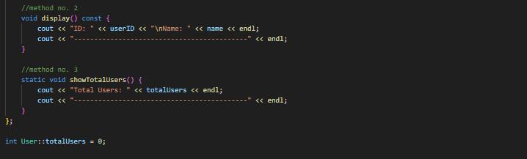

In main()
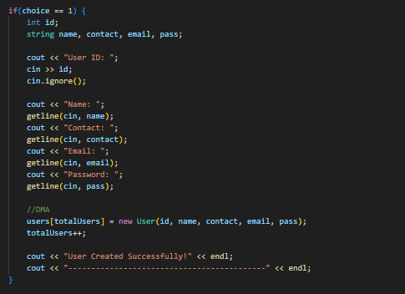

Explanation:
A new account is created when an instance of the class is made. Profile data is stored dynamically just like signing up on pakwheels website. Allows user to click for Sign Up, Fill the form, creating account, viewing and updation (similar to the website)

- Buyer & Seller Accounts
Feature on PakWheels: Some users are buyers, some are sellers. Buyers can browse vehicles; sellers can list vehicles.

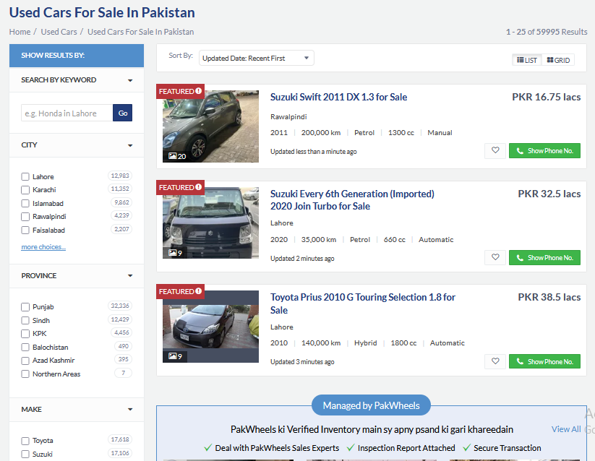
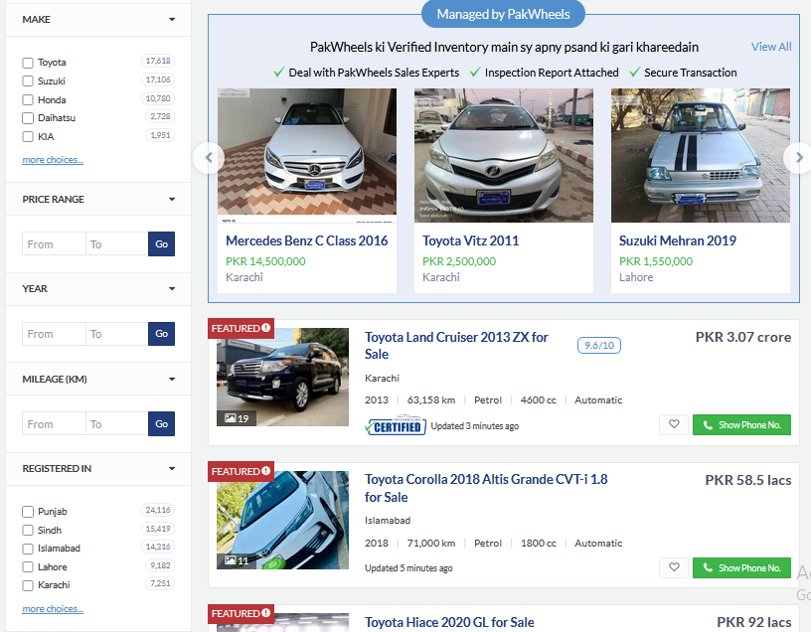

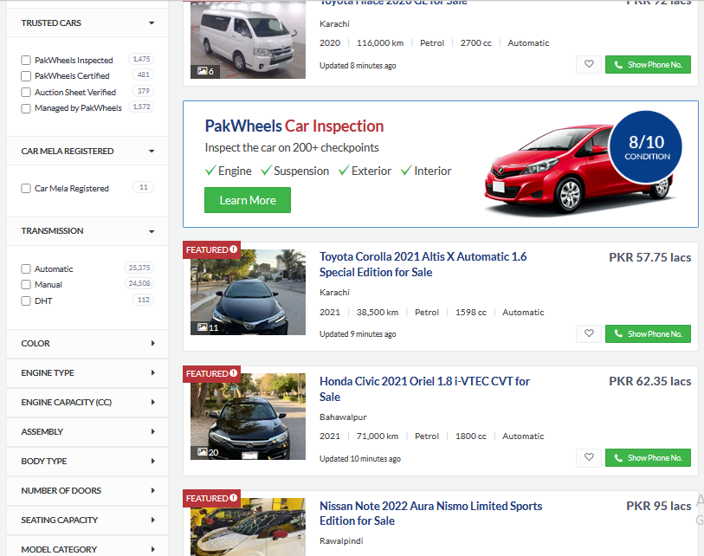

Code snippet of class and functionality in main():

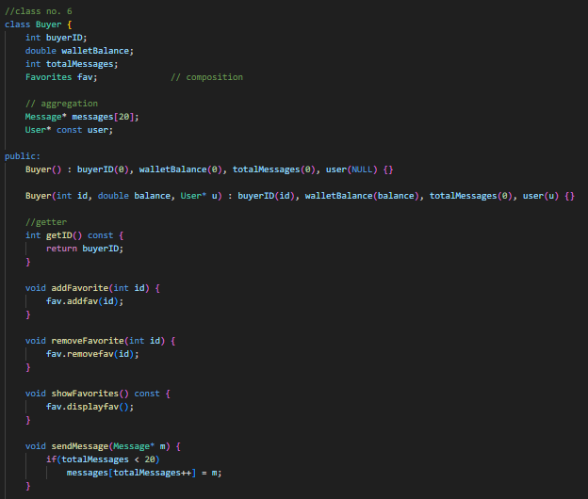

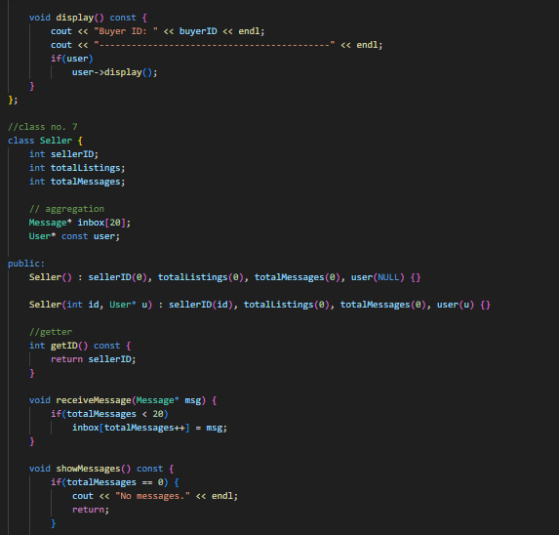
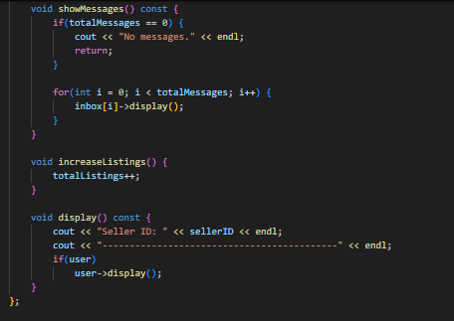

In main()

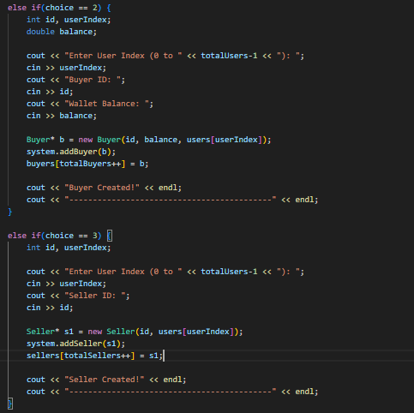

Explanation:
Users can have different roles such as Buyer or Seller, similar to the website. The base User class stores general profile information, while Buyer and Seller classes are linked to it using aggregation. Buyers can browse vehicles using the search functions and can also save favorites or send messages. Sellers can create listings through the Listing class and add them to the system. This separation of roles ensures that buyers and sellers have different functionalities

- Vehicle Listing with Detailed Specifications


Code snippet of classes and functionality in main():

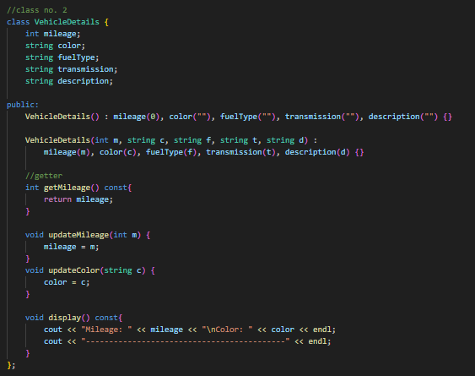

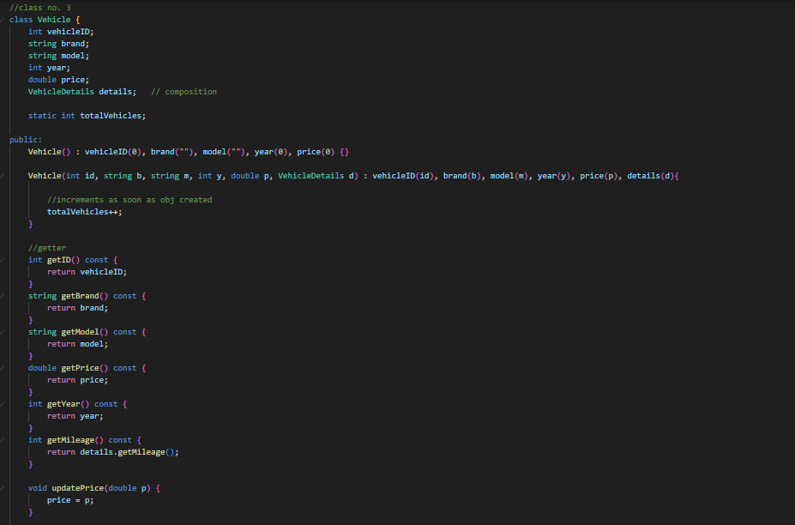
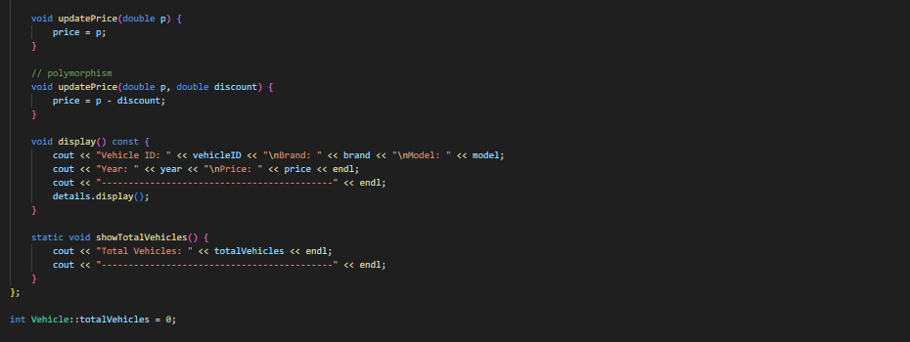

In main()

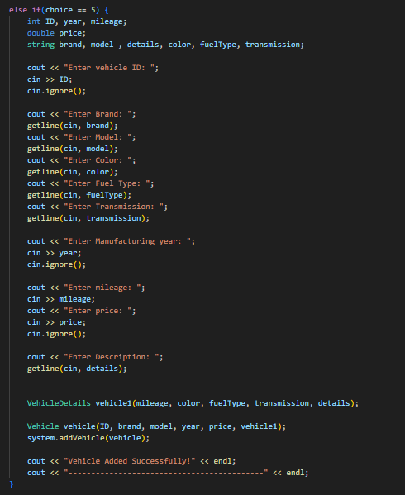

Explanation:
This feature allows sellers to list vehicles with complete specifications, similar to the website. The Vehicle class uses composition by containing a VehicleDetails object, ensuring that each vehicle stores full.
When system.addVehicle(vehicle); is called, the vehicle is added to the marketplace array. This mimics how sellers on PakWheels enter all car details before publishing a listing.

- Search Functionality
Feature on PakWheels: Users can filter/search vehicles by brand, model, year, price, or mileage



Code snippet of marketplaceSystem class and functionality in main():

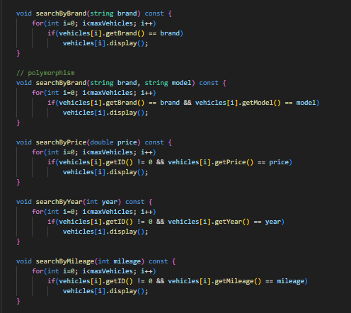

In main()

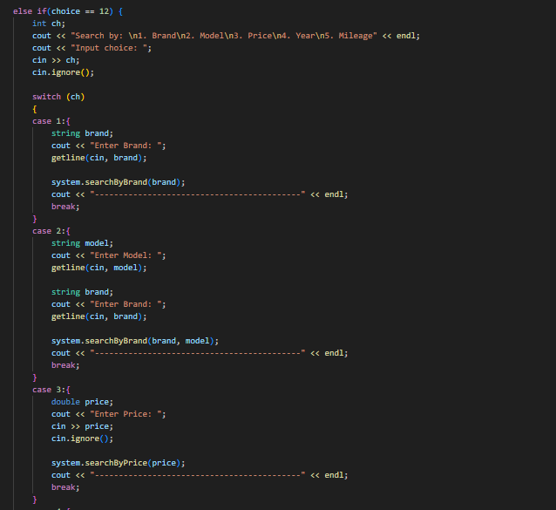

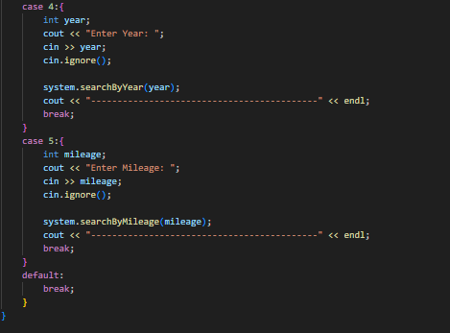

Explanation:
This feature allows users to search vehicles using multiple criteria such as brand, model, price, year, and mileage, similar to PakWheels.
In the marketplaceSystem class, separate search functions are implemented including

searchByBrand()
searchByPrice()
searchByYear()
searchByMileage()

Function overloading is used in searchByBrand() to allow searching by both brand alone and brand with model. Each function loops through the vehicle array and displays matching results

- Favorites / Wishlist
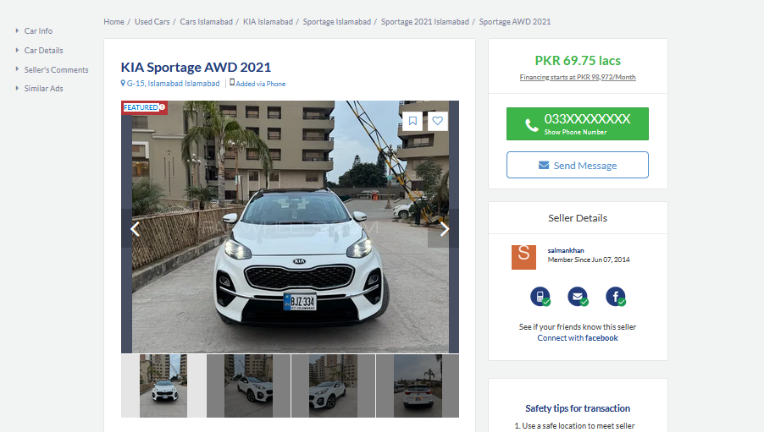
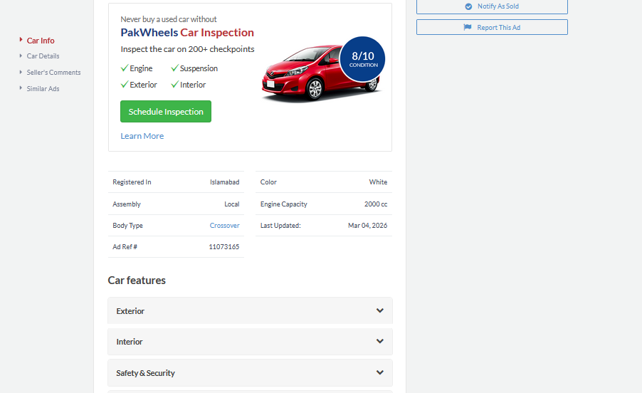

Code snippet of class and functionality in main():

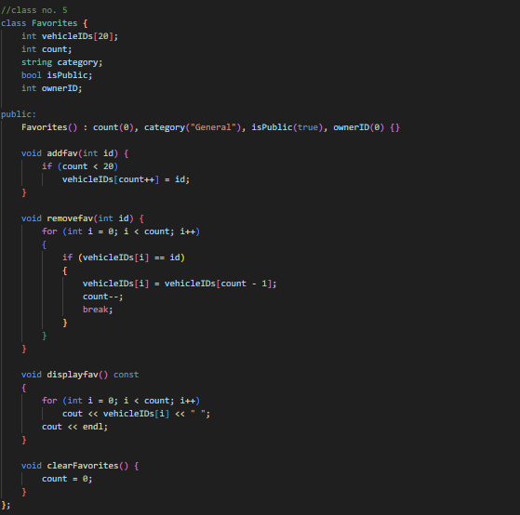
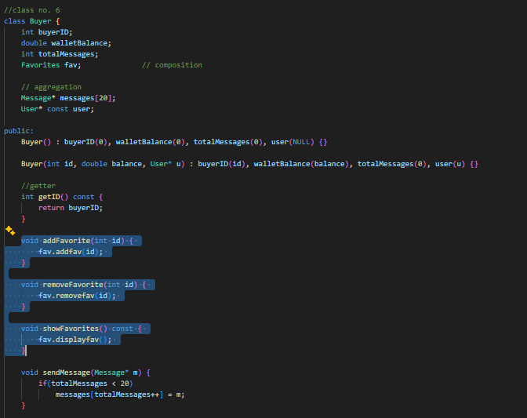

In main()

buyers[buyerIndex]->addFavorite(vehicleID);

Explanation:
This feature allows buyers to save vehicles for future reference, similar to the “Save Ad” option on PakWheels. In the Buyer class, composition is used to include a Favorites object that stores vehicle IDs. When addFavorite(vehicleID) is called, the selected vehicle ID is saved in the favorites list. The system maintains a list of saved vehicles for each buyer

Unified Modeling Language Diagram:
Previously:
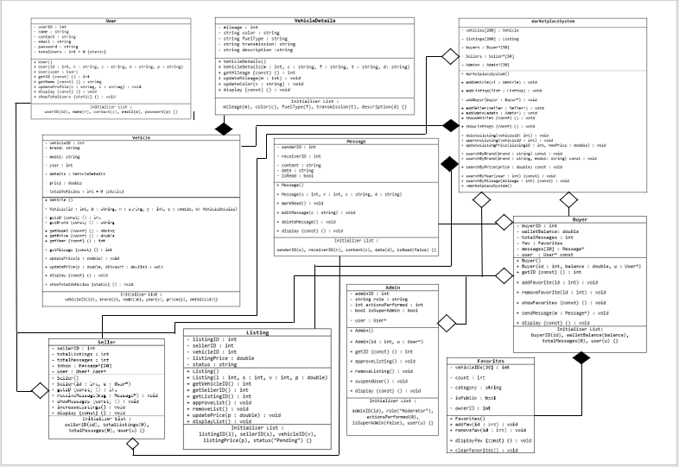

Currently:
